|  |  |
| --- | --- |
| aculty of Computer & Information Sciences  Ain Shams University  Subject: Professional Ethics & Legal Aspects  Year: (2nd year) undergraduate  Academic year: 2nd term 2019-2020 |  |

**Research Topic (2)**

**Title: The Ethics of Privacy Protection**

**Introduction**

**Privacy** isyour right to control how data about you is utilized, prepared, put stored, or shared. It’s also a basic right, fundamental to self-governance and the security of human dignity. If you ever go on the web, web security ought to be probably the greatest concern. Surf the web and you cannot help yet discover another tale about how much your own data is gathered while you make the most of your preferred sites.

**Information privacy** is a combination of:

1. **Communications privacy:**

Ability to communicate with others without being monitored by other persons or organizations

1. **Data privacy:**

Data privacy identifies with how a snippet of data or information ought to be handled and taken care of dependent on its relative significance and importance.

For example, you likely wouldn't see any problems with sharing your name with an outsider during the process of presenting yourself, yet there are other data you wouldn't share with anyone until you become progressively familiar with that individual.

**The bottom line**,

Data privacy is the ability to limit access to one’s personal data by other individuals and organizations so as to have a large degree of control over that data and its use.

**What’s Data Collection?**

**Data Collection** is the systematic approach to dealing with and measuring facts, statistics and data from a variety of sources to get a total and exact image of an area of interest. Data collection empowers an individual or organization to respond to relevant inquiries, questions, evaluate results and make expectations about future probabilities, patterns, and trends.

**A Comparison between data collection policies:**

|  |  |
| --- | --- |
| **Opt-in Policy** | **Opt-out Policy** |
| is the process used to describe when  a positive action is required to  subscribe a user to a newsletter list,  for example. | means that a user can be signed up  much more easily and he needs to be  given the possibility to opt-out easily |
| Organization must obtain specific permission from consumers before collecting any data. | Organization assumes that consumers approve of companies collecting and storing their personal information. |
| Favored by consumers. | Favored by data collectors. |

Example of Opt-in policy:

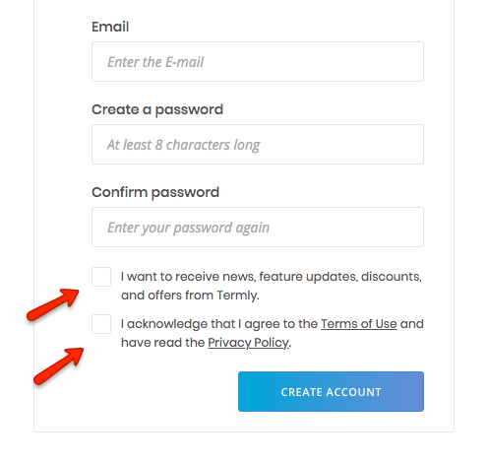

Example of Opt-out policy:

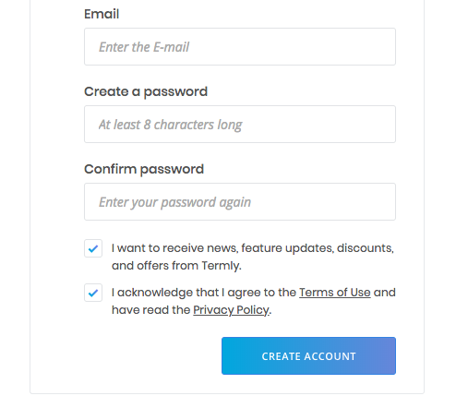

**With opt- in**, consumers must explicitly consent to third-party uses of personal data they wish to permit. In line with empirical evidence already referred to in the Introduction, we make the simplifying assumption that consumers find it too costly to opt in. As a result, all consumers prohibit that personal information about their purchasing patterns from related industries becomes publicly available. Firms therefore lack specific information about consumers before competing in the first period.

**The opt-out** system gives a consumer the option to stop sharing of its non-public information. As in reality very few consumers do exercise this option, we model that consumers do not opt out. An explanation for this consumer behavior is that opting out may be too costly to do, consumers are unaware of this option, or may not find it beneficial to exercise the option. Therefore, consumers make available non-public information through their past purchasing patterns at other firms..

**What does GDPR stand for?**

GDPR stands for General Data Protection Regulation. It's the core of Europe's digital privacy legislation.

**How did it come about?**

In January 2012, the European Commission set out plans for data protection change over the European Union so as to make Europe 'fit for the digital age'. Very nearly four years after the fact, agreement was reached on what that included and how it will be authorized. (GDPR) law was issued in 2016 and strongly activated in May 2018.

**What is GDPR?**

At its core, GDPR is a new set of rules designed to give EU citizens and residents more authority over their own data. It aims to ease the regulatory environment for business so both citizens and businesses in the European Union can completely benefit from the digital economy. It unifies the regulation within the EU.

**Understanding the importance of GDPR:**

Internet behavior has hugely changed. People send messages and emails, make bill payments, and shop online, entering personal details without even reconsidering and thinking twice. You can't agree more with this when you analyze how much personal information you may have shared. or where these details go. The data here refers to contacts, IP address, social media updates, banking information, online networking, and the history of the websites you browsed. The companies and organizations claim that they require these things to improve their customer service by being generally relevant, helpful, and useful. But does it have any facts? To address this inquiry and the concern, a new General Data Protection Regulation (GDPR) came into place.

**The importance of GDPR:**

The introduction of GDPR has immensely affected the way your business gathers, stores, and applies customer data today. One of the studies shows that only 20% of the companies hold fast to the new policy, while the majority of the small companies and even 60% of the tech companies haven't done anything concrete in this field. But not following the data protection rules can be harmful and destructive to your business, be it travel, retail, or tech-related. The new companies (startups) also cannot remain safe from their clutches. If you don't want to risk your business, then become GDPR agreeable.